Team Bits Please

User Manual

Advocacy App

# Login Screen -Username:

The user must enter their username in the field provided and click the next button to proceed.

If the user wants to stay logged in they must tick the “Remember me “option.

If the user does not have an account, they must register an account by pressing on the register button.

If a user is unsure of what any text on the screen is or what the buttons do, they can just press and hold on these items for a few seconds and the application is going to read them out to them

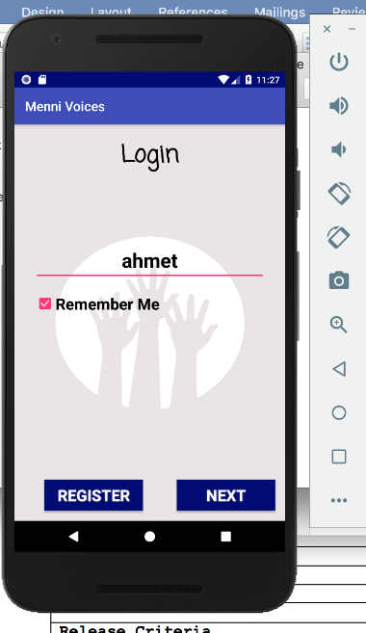

# Register Screen:

The user must register an account before the can use the application.

The user should fill out all the fields accordingly. If a user is unsure of what any text on the screen is or what the buttons do, they can just press and hold on these items for a few seconds and the application is going to read them out to them

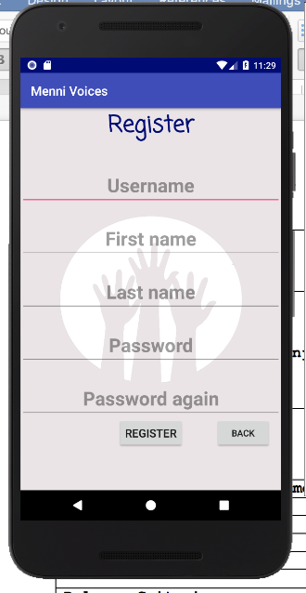

# Login Screen – Password:

The user must enter in their four-digit combination, by taping on the corresponding number on the number grid, to proceed with logging in.

If the user enters in a wrong digit, they can just press the arrow button to delete the error.

If a user is unsure of what any text on the screen is or what the buttons do, they can just press and hold on these items for a few seconds and the application is going to read them out to them

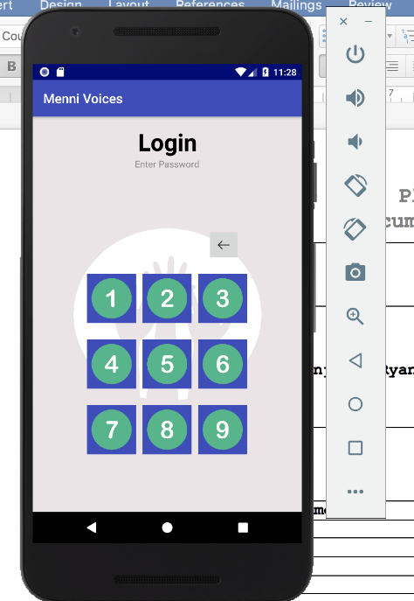

# Main Menu Screen:

The user can choose which option they want to choose, by clicking on one of the images on the screen. If the user is unsure of what each image does and what option it provides they can just press down and hold on the images for a few seconds and the app will read out the functionality to them.

If a user is unsure of what any text on the screen is or what the buttons do, they can just press and hold on these items for a few seconds and the application is going to read them out to them

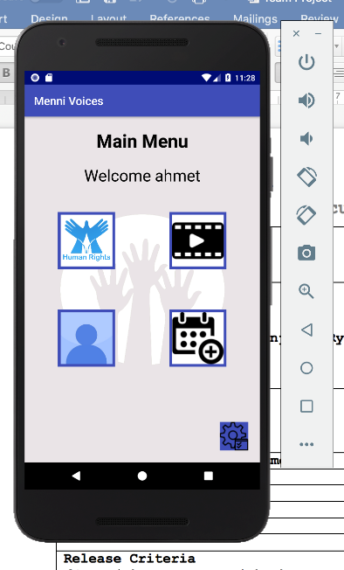

# List of Human Rights Screen:

If a user has selected to view the list of human rights they will be displayed a list of human rights.

If a user wants to search for a specific right, they can’t tap on the search bar and type the name of the right they are looking for. Once the user has finished typing, they just press search and the list will be updated with their results, if one was found.

If the user wants to read more about a specific right they can just tap the read button below the name of the human right and they will be brought to a page with more information on this specific human right

.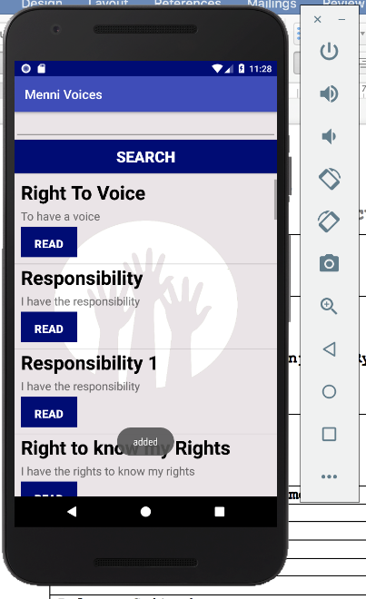

# More information on a specific right screen:

If the user has clicked on a specific right to find out more about it, they would be redirected to this screen.

If the user cannot read what it says on the screen they can just tap on the text and hold for a few seconds, until the application reads it out to them.

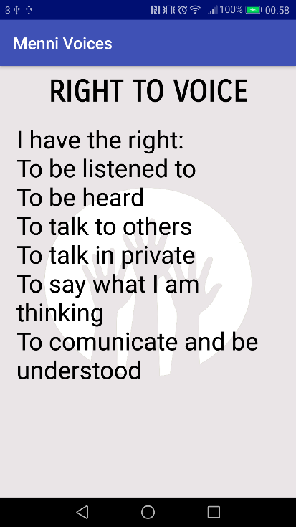

# List of videos of meeting minutes:

If the user has selected the option to view the videos from the meetings they will be redirected to this screen. Here a list of all available videos will be displayed to the user. If the user wants to view a video they can just click onto any one of the videos and they will start playing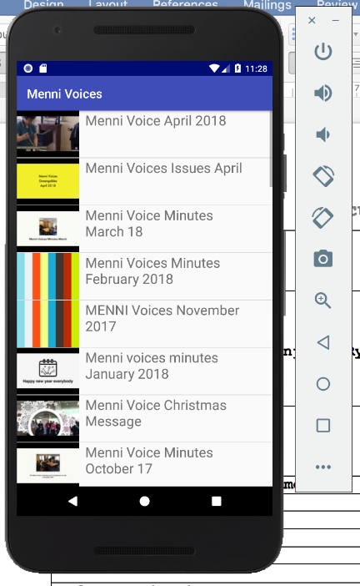

# Profile Screen:

If the user has tapped on the option to view their profile they will be greeted with this screen. Here they can update their password by typing in their old password in the required field and then the new password in the required field. After that all they have to do is tap the change password button and their password will be changed.

If a user is unsure of what any text on the screen is or what the buttons do, they can just press and hold on these items for a few seconds and the application is going to read them out to them

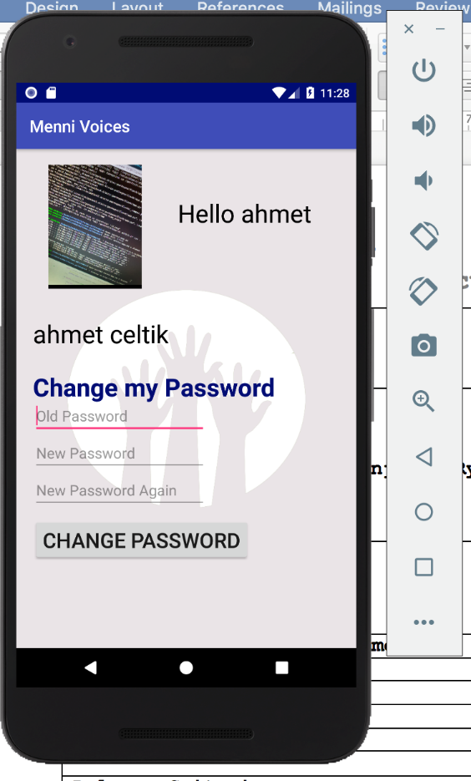

# Events Page:

If the user has chosen to view the events, he will be greeted by this screen. Here a list of events will be displayed to them. If a user wishes to read more details about the even they can click on the details button to be brought to another screen with more details about the event.

If a user is unsure of what any text on the screen is or what the buttons do, they can just press and hold on these items for a few seconds and the application is going to read them out to them

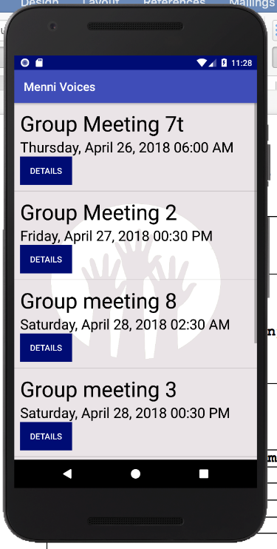

# Event Details:

If the user has clicked to see more details about an even they will be redirected to this screen where, they can read about the event. The can also edit or delete information about the even if they are an admin user, by clicking on the corresponding buttons

If a user is unsure of what any text on the screen is or what the buttons do, they can just press and hold on these items for a few seconds and the application is going to read them out to them

# 

# Administrator Tools:

If the user is an admin user, he will have the option of administrator tools which will allow them to add events, view user information and manage user accounts.

The user can choose on of the options by clicking on one of the two buttons

If a user is unsure of what any text on the screen is or what the buttons do, they can just press and hold on these items for a few seconds and the application is going to read them out to them

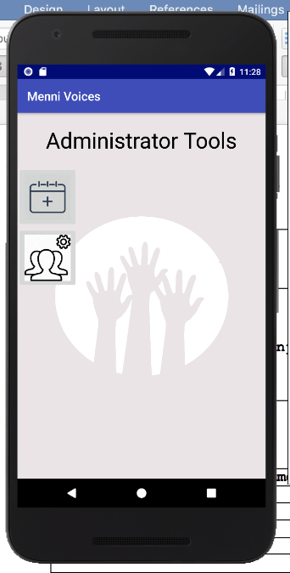

# Add an event:

If the user has chosen to the option to add an event, they will be greeted with this screen. Here they will be able to create an event by filling out the required fields and pressing the create/update button.

If a user is unsure of what any text on the screen is or what the buttons do, they can just press and hold on these items for a few seconds and the application is going to read them out to them

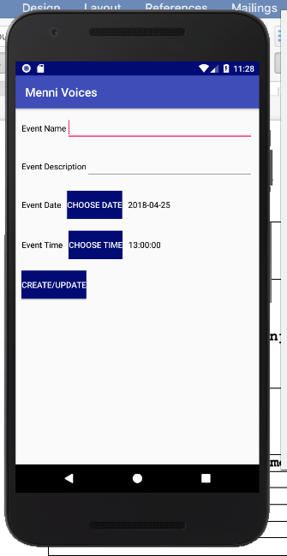

# View User information:

If the admin user has chosen, the option to view the user information they will be greeted with this screen. Here they will be able to see with a list of information about each user and they will also be able to manage the user accounts by tapping on the manage button

If a user is unsure of what any text on the screen is or what the buttons do, they can just press and hold on these items for a few seconds and the application is going to read them out to them

# 

# Manage User accounts:

If the user had selected the option to manage the user accounts, they will be greeted with this screen. Here the admin user will be able to change the password for a user, to delete their account or remove their admin status

If a user is unsure of what any text on the screen is or what the buttons do, they can just press and hold on these items for a few seconds and the application is going to read them out to them

